EXPERIMENT 8
Ex. No.: 8
Analysis of Electromagnetic Waves across Two Parallel Plates: Critical and Guide Wavelength
AIM: To analyse the propagation of electromagnetic waves between two parallel plates and to find the critical wavelength and guide wavelength using Scilab.
SOFTWARE REQUIRED: Scilab 6.1.1
PROGRAM
clear; clc;
a=0.04; f=5e9; c=3e8;
lambda=c/f; lambdac=2*a;
if lambda < lambdac then
lambdag=lambda/sqrt(1-(lambda/lambdac)^2);
printf("Critical wavelength = %.4f m\n",lambdac);
printf("Free-space wavelength = %.4f m\n",lambda);
printf("Guide wavelength = %.4f m\n",lambdag);
else
printf("Below cut-off: no propagation\n");
end
TEST CASES AND OUTPUT
Test Case 1: Plate spacing a=0.04 m, f=5 GHz
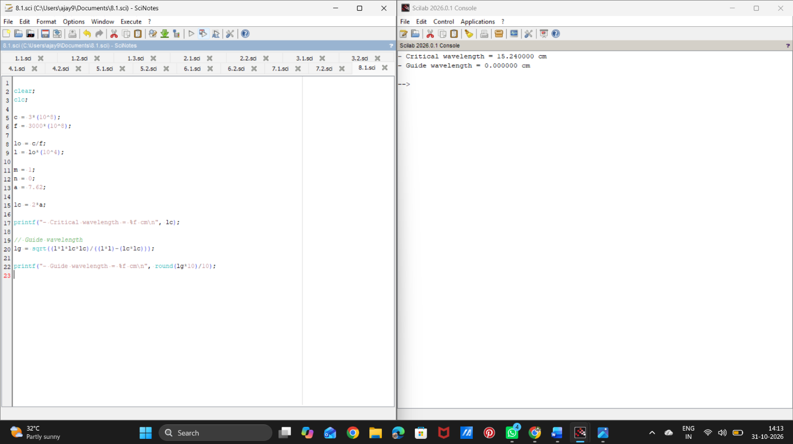

Test Case 2: Plate spacing a=0.05 m, f=6 GHz
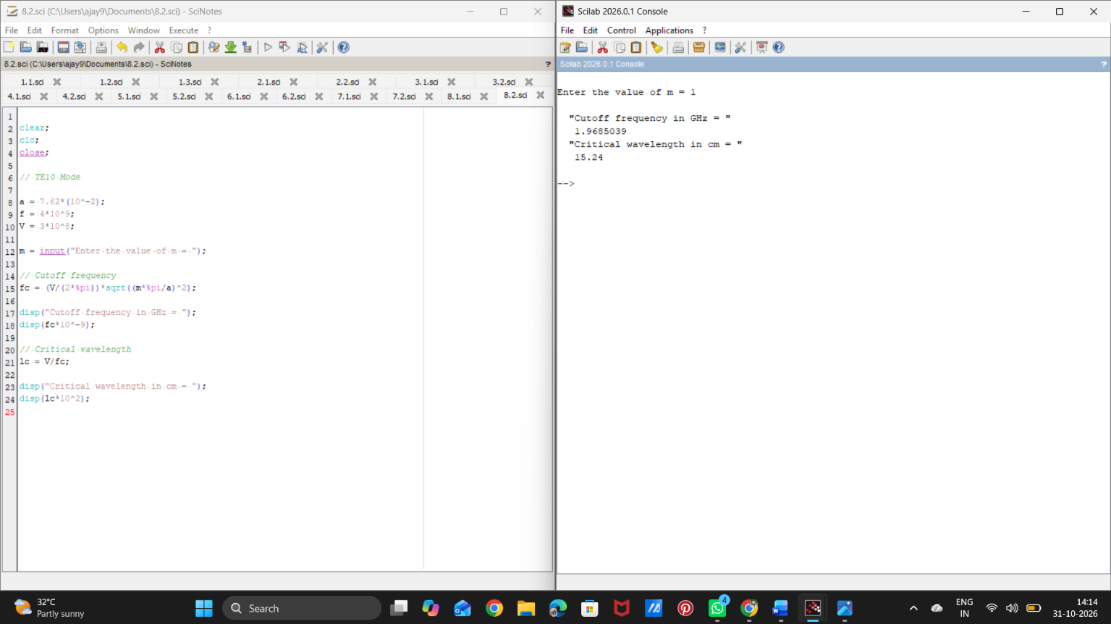
RESULT
Thus, the critical wavelength and guide wavelength between two parallel plates were calculated using Scilab.

